**Extract text from images using Azure AI Vision**

**OCR - Optical Character Recognition**

OCR or Optical Character Recognition is also referred to as text recognition or text extraction. Machine-learning-based OCR techniques allow you to extract printed or handwritten text from images such as posters, street signs and product labels, as well as from documents like articles, reports, forms, and invoices. The text is typically extracted **as words, text lines, and paragraphs or text blocks**, enabling access to digital version of the scanned text. This eliminates or significantly reduces the need for manual data entry.

**How is OCR related to Intelligent Document Processing (IDP)?**

Intelligent Document Processing (IDP) uses OCR as its foundational technology to additionally extract structure, relationships, key-values, entities, and other document-centric insights with an advanced machine-learning based AI service like [Document Intelligence](https://learn.microsoft.com/en-us/azure/ai-services/document-intelligence/overview). Document Intelligence includes a document-optimized version of **Read** as its OCR engine while delegating to other models for higher-end insights. If you are extracting text from scanned and digital documents, use [Document Intelligence Read OCR](https://learn.microsoft.com/en-us/azure/ai-services/document-intelligence/prebuilt/read).

**How to use OCR**

Try out OCR by using Vision Studio. Then follow one of the links to the Read edition that best meet your requirements.

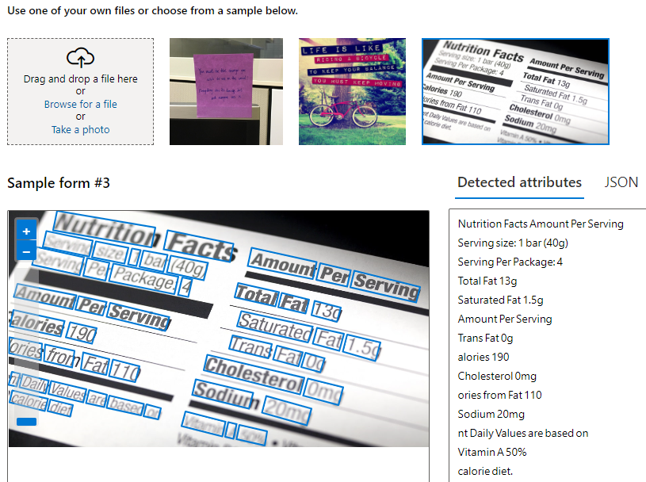

**OCR common features**

The Read OCR model is available in Azure AI Vision and Document Intelligence with common baseline capabilities while optimizing for respective scenarios. The following list summarizes the common features:

* Printed and handwritten text extraction in supported languages
* Pages, text lines and words with location and confidence scores
* **Support for mixed languages**, **mixed mode** (print and handwritten)
* Available as Distroless Docker container for on-premises deployment

**Input requirements**

The **Read** API takes images and documents as its input. The images and documents must meet the following requirements:

* Supported file formats are JPEG, PNG, BMP, PDF, and TIFF.
* For PDF and TIFF files, up to 2,000 pages (only the first two pages for the free tier) are processed.
* The file size of images must be less than 500 MB (4 MB for the free tier) with dimensions at least 50 x 50 pixels and at most 10,000 x 10,000 pixels. PDF files don't have a size limit.
* The minimum height of the text to be extracted is 12 pixels for a 1024 x 768 image, which corresponds to about 8-point font text at 150 DPI.

**Azure AI Vision v4.0 Read OCR**

The new Azure AI Vision Image Analysis 4.0 REST API offers the ability to extract printed or handwritten text from images in a unified performance-enhanced synchronous API that makes it easy to get all image insights including OCR results in a single API operation. The Read OCR engine is built on top of multiple deep learning models supported by universal script-based models for [global language support](https://learn.microsoft.com/en-us/azure/ai-services/computer-vision/language-support).

**Text extraction example**

The following JSON response illustrates what the Image Analysis 4.0 API returns when extracting text from the given image.



